College of Allied Health Sciences
7th Annual Student Research Day
April 26, 2023




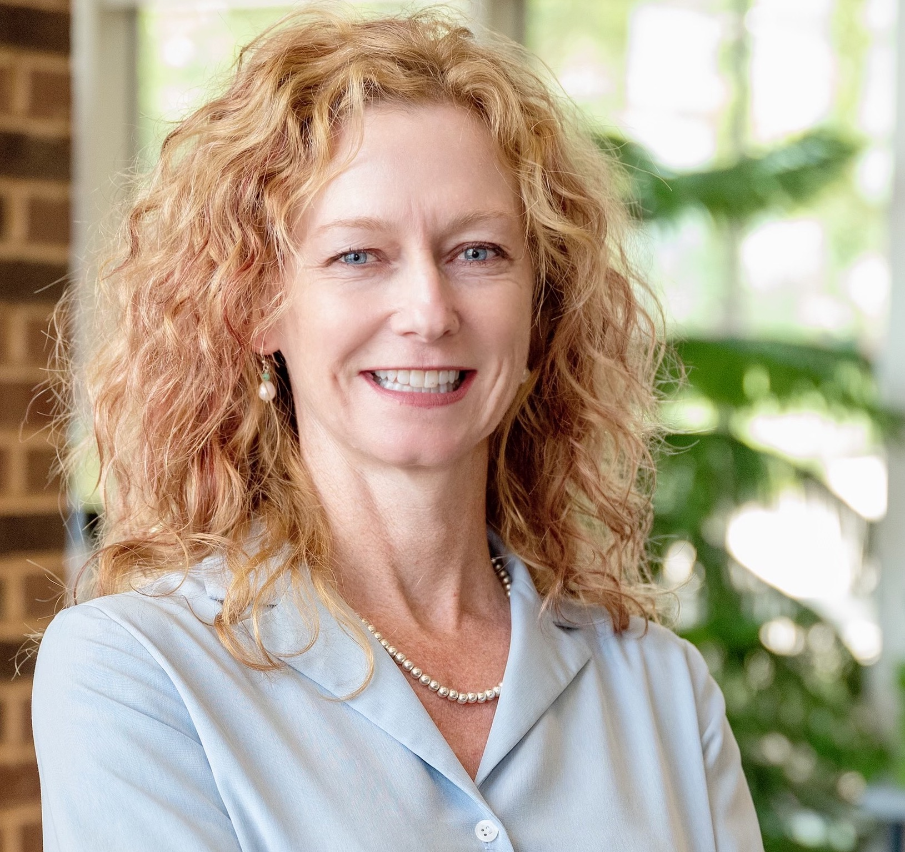

Welcome to the 7th Annual College of Allied Health Sciences Research Day. We are excited to continue this tradition and recognize the outstanding research and scholarly work presented by our students! We have a wonderful program this year with students from nearly every degree program in the college and at all levels - undergraduate, professional graduate, and research doctorate, presenting. Our students and their faculty mentors have been incredibly productive this year addressing health-related issues to improve the function and quality of life and reduce disability across the lifespan. As you will see, the program is filled with collaborative research - students working together to address health-related issues and students collaborating with faculty in their programs and across other departments in the college and the university to answer clinical questions and improve the quality of healthcare. It is through these collaborations that we are able to transform our region by improving the health-related issues affecting the residents of eastern North Carolina and beyond. Please attend the oral presentations and visit the posters to learn more about the research and scholarly pursuits our students have completed over the past year.
Hope you enjoy the event!
All best,

Heather Harris Wright, PhD Ashley Burch, PhD., HSIM
Associate Dean for Research Chair, CAHS Research Committee

Welcome

Summary of Events

Wednesday, April 26, 2023
9:00-10:20 AM
Opening remarks & Oral Presentations Session A
10:30- 12:00 PM
Poster Presentations Session A
12:00- 12:30 PM
Lunch Break
12:30- 2:00 PM
Poster Presentations Session B
2:00- 3:15 PM
Oral Presentations Session B
3:15- 4:00 PM
Keynote Speaker
4:00- 4:15 PM
Award Presentation & Closing Remarks
Poster Presentation Session A
MC01. Driving and Community Mobility Bootcamp for Young Adults with Autism Spectrum Disorder: Participants’ Perception of Bootcamp as an Occupational Therapy Intervention Skylar Rogan, Charli White, Anne Dickerson
MC02. The Effect of Male vs Female Target Voices in Speech Recognition. Erin Kokinda, Andrew Vermiglio, Virginia Driscoll, Caitlyn Paulson, Reyse Stirrett, Ava Conningham, Kathryn Fennie, Laura Hall, Abigail Ormond
MC03. The Effect of Target Speaker Sex on Monosyllabic Word recognition in Quiet Ability. Caitlyn Paulson, Andrew Vermiglio, Virginia Driscoll, Erin Kokinda, Drew Huffman, Gabby Musumeci, Et. al.
MC04. Does Daily Use of Prolonged Speech Patterns Benefit People Who Stutter Nathalia Cannon, Patrick Briley
MC05. Activity Levels, Perceived Exertion, & Person Factors During Instrumental Activities of Daily Living in Community-Dwelling Older Adults Madison Irvin, Paige Lawrence, Kendyl Finley, Young Joo Kim
MC06. Reliability of Hand-Held Dynamometry of Testing Shoulder Strength in Healthy Individuals Kirstan Beaver, Wiley Hoover, Michael Garrison, Shellie Zsoldos
MC07. Simulated Bone Growth: Implications for Physical Activity Related Bone Stress. Hannah McLendon, John David Willson, Stacey Meardon
MC08. The Validation of Virtual Reality Sensory Organization Test to Evaluate Postural Control. Keri Price, Chia-Cheng Lin, Avery Vose, Rui Wu
MC09. Walking in a high fall risk environment and its effects on metabolic energy expenditure Brian McGill, Ryan D Wedge
MC10. Segment Coordination During Perturbed Symmetric and Asymmetric Walking Ashley Arensdorf, Ryan Wedge
MC11. HIIT as a Preventative Measure for Normal Age-Related Cognitive Decline Justin Stephenson Gabe Gonzales-Contreras, Ted Graber

Oral Presentations Session A
RD01. Investigating Changes in Spatiotemporal Upper Extremity Characteristics after Short and Intensive Bimanual Training Sessions in Children with Unilateral Cerebral Palsy Shailesh S. Gardas, John Willson Destiny Alling Erica Boswell Tom Jaskson Christine Lysaght Swati M. Surkar
RD02. Behavioral and transcriptome profiling of heterozygous Rab10 knockout mice Wyatt Bunner, Jie Wang, Sarah Cohen, Denys Bashtovyy, Tuan Tran, Ryohei Yasuda, Erzsebet Szatmari
RD03. Speech Accommodation for Older Adults: A Scoping Review Rose Baker, Catherine Nobles, Heidi Reis, Susan Bobb, Kathrin Rothermich
RD04 Effect of Load carriage on Patellofemoral stress in females Ankur Padhye, Stacey Meardon, Junfei Tong, Jaques Reifman, and John Willson
MC01. Examining Visual Processing Speed Reaction Time as a Predictor for Driving Fitness Meagan Denny, Alec DuCharme, Anne Dickerson
MC02. Examining multi-tasking ability on an interactive driving simulator task to differentiate between fit and unfit drivers Alec DuCharme, Anne Dickerson
MC03 Effects of a Prolonged Run on Tibia Bone Stress in Females and Males Dylan Sampson, Stacey Meardon, John Willson

MC17. The Etiology and Prevalence of MSK Injuries in Volleyball Players and Evidence-Based Strategies for Prevention Briana Yanello, Junae Staples, Michael Garrison
UG07. Reduction of Screen Time Spent Using an Electronic Device Alyssa Jones, Robert Campbell
MC18. Effects of Training on Bimanual Skill Learning: a Comparative Study Between Typically Developing and Children with Unilateral Cerebral Palsy Anna Apperson, Mary Scott Faircloth, Swati Surkar
MC19. A Potential Role for Skeletal Muscle in Development of Metabolic Disease Lindsay Mitchell, Fliip Jevtovic, Nicholas Broskey, Joseph Houmard, Donghai Zheng, Lynis Dohm, Terry Jones
UG08. The Effect of Musical Experience on Speech Recognition in Noise Ability Melissa Rafaniello, Andrew Vermiglio, Virginia Driscoll, Caitlyn Paulson, Erin Kokinda, et al.
UG09. The Relationship Between Working Memory and Speech Perception in Noise Ability Emily Harrison, Andrew Vermiglio, Virginia Driscoll, Caitlyn Paulson, Erin Kokinda, et al.
MC20. Running Shoe Midsole Cushioning Influences Tibial Stress During Running Shoes Lauren Dicktel, Stacey A Meardon, John D Willson
UG10. The Effect of COVID-19 Infection on Behavioral Measures of Auditory Function Laney Pope, Andrew J. Vermiglio, Virginia Driscoll, Erin Kokinda, et al.
UG11. Morphology of the Levator Veli Palatini Muscle: Volumetric Assessment McKenzie Perry, Neda Tahmasebifard, Eshan Schleif, Jamie Perry
RD01. Quantitative Changes in Velopharyngeal Anatomy Following Buccal Flaps for Velopharyngeal Insufficiency Management Taylor Snodgrass, Thomas Sitzman, Jessica Williams, Jamie Perry, et al.
MC21. Policy Change Reduces No-Show Visits in Pro-Bono PT Student Run Clinic Natalie Bryie, Gabrielle Lane, Christine Lysaght
MC22. Determining the Relationship Between Clinical Symptoms and Oculomotor Measures in People with Concussion Ashley King, Shellie Zsoldos, Chia-Cheng

Poster Presentations Session A
UG01. Feasibility of using accelerometer data to quantify performance and compare to capacity measured clinically in children with cerebral palsy. Grant Kirkman, Shailesh Gardas, Casey Burroughs, Swati Surkar
MC12. Age Related Changes in the Calcium Handling Properties of Skeletal Muscle in Mice Justin McCrary, Ted Graber
MC13. Retention of Bimanual Performance Following Hand-Arm Bimanual Intensive Therapy in Children with Unilateral Cerebral Palsy Casey Burroughs, Paxton Dettor, Shailesh Gardas, Christine Lysaght, Swati Surkar
MC14. Video fluoroscopic Detection Sensitivity of Swallowing Landmarks following Radiotherapy for Head and Neck Cancer Deirdre Larsen, Caela Collichio, Melda Kunduk, Andrew McWhorter

UG02. How Perspective Shapes Social Behaviors: A Study on Speech Accommodation Daisha Dowson, Rose Baker, Jaeyoung Kum, Susan Bobb, Kathrin Rothermich
UG03. Experiences from Analyzing Nasopharyngoscopy Data: Quality Improvement Suggestions Lydia LaFevers, Taylor Snodgrass, Kathryn Fennie, Imani Gilbert, Thomas Sitzman Jamie Perry
MC15. Remote ischemic conditioning effects on gait kinematics and muscle recruitment in children with cerebral palsy Emma Weis, Shailesh Gardas, John Willson, Swati Surkar
UG04. The Effect of Eye Closure on Speech Perception in Noise Ability Trenton Barnett, Andrew Vermiglio, Virginia Driscoll, Caitlyn Paulson, Erin Kokinda, Drew Huffman, Gabriela Musumeci, Alyssa Alford, et al.
UG05. Effect of Risk for Cochlear Synaptopathy and Musical Experience on Speech Recognition in Noise Ability Kaitlin Abrams, Andrew Vermiglio Virginia Driscoll, Huffman Erin Kokinda, Gabriela Musumeci, Caitlyn Paulson, Alyssa Alford, et al.
MC16. Driving and Community Mobility Bootcamp for Young Adults with Autism Spectrum Disorder: Perceptions of Law Enforcement Lindsay Diab Madison Rogan
UG06. Investigating the relationship between compensatory misarticulation errors and hypernasality severity Hannah Ragsdale, Jessica Williams, Imani R. Gilbert, Jamie Perry

Poster Presentations Session B
MC25. The Effects of Age on Endothelial Response to High Intensity Interval Training Gabriel Gonzalez-Contreras Megan L. Pajski, Ted G. Graber
UG12. A Mixed Methods Review of the Fresh Start Program. Grace Regan, Lauren Sastre
UG13. Standardizing Brake Force. Makenzie Steidl, Anne Dickerson
UG14. The Effect of Tinnitus on Speech Perception in Noise Ability. McKenzie Perry, Andrew J. Vermiglio, Virginia Driscoll, Caitlyn Paulson, Erin Kokinda, Drew Huffman, Gabriela Musumeci, Kaitlin Abrams, Alyssa Alford, et al.
UG 15. The Relationship Between Speech Recognition in Noise vs Dichotic Digits Performances. Katelyn Overcash, Andrew J. Vermiglio, Virginia Driscoll, Erin Kokinda, Drew Huffman, Gabriela Musumeci, Kaitlin Abrams, Alyssa Alford, et al.
UG16. Chronic Disease Prevalence, Morbidity rates, and Management Strategies in rural United States: A Comparative Literature Review Ava Asbell, Ashley Burch, Linda Bolin
UG17. HIIT Training and Preservation on Muscle and Mitochondrial Function in Mice. Hayden Carter, Justin Stephenson, Ted Garber
UG18. Exploring the Relationship Between Stuttering and Issues Related to Hearing Anna Scott Ivey, Patrick Briley, Molly Jacobs
UG19. The Relationship between the Ratings of ADHD Symptoms vs. Speech Recognition in Noise Ability Kelly Dorman, Andrew Vermiglio, Virginia Driscoll, Caitlyn Paulson, Erin Kokinda, Drew Huffman, Gabby Musumeci, Kaitlin Abrams, Alyssa Alford, et el.

RD03. Quantitative Changes in Velopharyngeal Anatomy Following the Furlow Double-Opposing Z-Plasty for Velopharyngeal Insufficiency Management Taylor Snodgrass, Thomas J. Sitzman, Jessica L. Williams, Davinder J. Singh, Jeffrey Miller, Patricia Cornejo, Michael Kuwabara, Jamie L. Perry
RD04. Neuro-immune interactions in heterozygous Rab10 knockout mice Wyatt Bunner, Lauren Grodi, Jonathan Jacob Carver, Debajit Bhowmick, Alessandro Didonna, Erzsebet M. Szatmari

Oral Presentations Session B
Mc04. The Social and Emotional Influence of Group Engagement in Occupations Among Cancer Survivors Heidi Kreis, Lynne Murphy
MC05. Adding Somatosensation Thresholds to Improve the Steadi Fall Risk Screening Algorithm Alyssa Adamkowski, Chia-Cheng Lin, Taylor Luibrand, Natalie McBryde, Abby Volz, et al.
MC06. Medical Students' Perceptions of Physical Therapy: An Opportunity for Interprofessional Collaboration Heather Hubeli, Christine Lysaght, Natalie Bryie, Gabrielle Lane
MC07. Velopharyngeal MRI Predictors of Success and Quality Assessment in Multi-Site Observational Study Kathryn Fennie, Taylor Snodgrass, Thomas Sitzman, Jamie Perry
MC08. Clinical predictors of tibiofemoral joint contact force asymmetry during running following anterior cruciate ligament reconstruction Rachel Donaldson, John Willson, Ankur Padhye, Stacey Meardon
UG01. Change Management: Losing Weight by Using Isagenix Meal Replacement Shakes, Isagenix Dietary Supplements, and Intermittent Fasting Robyn Hamilton, Robert Campbell
UG02. Multi-omics analysis of nutrient metabolism reveals novel role for B12 neuro-inflammatory regulation Abigail Dickerson, Michael Wheeler
Poster Presentations Session B
MC23. Factors Influencing Gross Motor Development During the First Year of Life in Typically Developing Infants: A Rapid Review. Sarah Coward, Christina Larkins-Roach, Kara Kern, Jamie E. Bloss, Linda E. May, Amy Gross McMillan
MC24. The Relationship between Monosyllabic Word Recognition in Quiet VS. Speech Recognition in Noise Test Results. Drew Huffman, Andrew J. Vermiglio, Virginia Driscoll, Caitlyn Paulson, Erin Kokinda, Gabriela Musumeci, Kaitlin Abrams, et al.
RD02. MRI Study of the Velopharyngeal Closure Location in Relation to the Palatal Plane Neda Tahmasebifard, Taylor Snodgrass, Kevin O'Brien, Jamie Perry

MC34. The Impact of Blood Flow Restrictions on strength and Coordination of a Young Adult with Quadriplegic Cerebral Palsy Taylor Lucas, Sarah Johnson, Swati Surkar, Shailesh Gardas
MC35. A Convergent Validity Study: Listening in Spatialized Noise-Sentences (LiSN-S) Test and the BKB-SIN Test. Gabriela Musumeci, Andrew J. Vermiglio Virginia D. Driscoll, et al.
UG23. The Relationship Between Self-Reported Symptoms of Attention Deficit Hyperactivity Disorder (ADHD) vs Speech Recognition in Noise Ability. Alyssa Alford Andrew Vermiglio Virginia Driscoll Kaitlin Abrams Julia Bak Trenton Barnett, et al.
UG24 Associations Between Social Determinants of Health and Diabetes Self-Care Behaviors Among Insured Patients Sarah Elliott, Ashley Burch, Linda Bolin
UG25. The Relationship between Stigma and Mood Outcomes for College Students with Disabilities Caroline Knox, Christy Walcott
MC36. Exploring the Relationship Between Praxis & Handwriting Legibility in Elementary Students Denise Donica, Larymi Beck, Kathryn Hill
MC37. Characterizing Nationally Available Gelatin-Based Products using IDDSI Testing Methods Meghan Eisenhardt, Abigail Perrini, Mathew Vansant, Deirdre Larsen

Poster Presentations Session B
MC26. Surviving to Thriving: Qualitative Perspectives on an Occupation-based Cancer Survivorship Group Ayoola Ajani, Logan Leggett, Lynne Murphy
MC27. Aphasia Subsequent to Stroke in Adults with Williams Syndrome and Autism: Where are the cases? Sierra Silva, Rhiannon Phillips, Jamie E. Bloss, and Matthew Walenski
UG20. Centaurinα1-Bid Signaling in Alzheimer’s Disease Progression Mary Phipps, Wyatt Bunner, Denys Bashtovyy, Ryohei Yasuda, Erzsebet M. Szatmari
UG21. An Investigation of Gravity’s Impact on the Velopharyngeal Mechanism Haley M. Masterjohn, Imani R. Gilbert, Eshan Schleif, Jamie L. Perry
MC28. Exploring Readiness for Mobility Transitions Among Older Adults Being Evaluated for Fitness to Drive Claire Gardiner, Phoebe LaCroix, Lynne Murphy
MC29. Effects of Remote Limb Ischemic Conditioning on Peripheral Sensations and Hand Grip in Children with Unilateral Cerebral Palsy David Turnure, Michaela Larrison, Chia-Cheng Lin, Swati M. Surkar
MC30. The Effect of Hamstring Length on Ground Reaction Force in Pitchers Tommy Houmard, Lydia Tart, Joey Casadonte, MS Alex Durland, Brandon Young
RD05. Potential Clinical Applications of a Velopharyngeal Atlas Tool Imani R. Gilbert, Jamie L. Perry, Fangxu Xing Riwei Jin David P. Kuehn, Ryan K. Shosted, Jonghye Woo, Zhi-Pei Liang, Bradley P. Sutton
MC31. Tibiofemoral Joint Contact Forces with Slip Perturbations During Symmetric and Asymmetric Walking Alexander S. Clark, Madison Deanes, John D. Willson, Ryan D. Wedge
MC32. Parent Perceptions of Effects of a Driving and Community Mobility Bootcamp in their Children with Autism Spectrum Disorder Emily Kron, Kelly Oglesby, Anne Dickerson
UG22. Handwriting Abilities of Low-SES Elementary Students Compared to Grade-Level Expectations Ashley Jones, Denise Donica
MC33. Effects of an Occupational Therapy Ground-Based Horsemanship Program on Executive Function and Social Participation in Children and Youth with Disabilities: A Pilot Study Dani Campbell, Jill Donaldson, Ella Duffy, Lydia Mead, Ashley Wilhite, Heather Panczykowski

QR code – People’s Choice Voting! 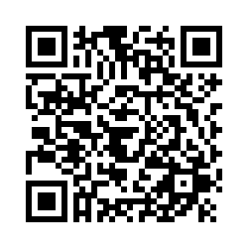

Keynote Speaker
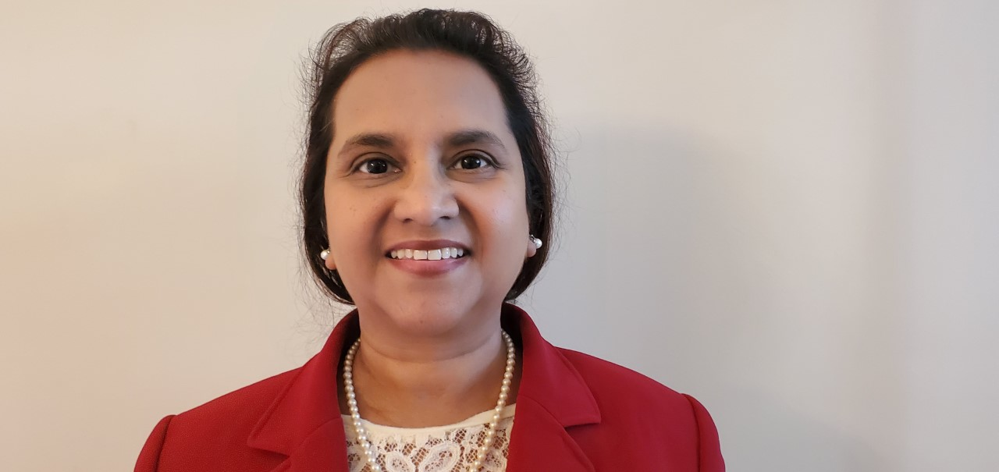
Dr. Nancy Dias is an Associate Professor in the Nurse Science Department at the College of Nursing. Her work experience in nursing includes both experiences in the United States and internationally (India and Oman) as a clinician, educator, administrator, and a researcher. She completed her PhD at Duke University School of Nursing and a 1-year T32 post-doctoral fellowship from Indiana University School of Nursing. As a researcher, she has a niche for a very significant and innovative aspect of pediatric palliative care services that includes parent caregiver health outcomes, their bereavement processes, and innovative techno. She strives to lay the foundations to develop a body of research that can make innovative and significant contributions in palliative, end of life care, and bereavement care with a focus on developing and testing interventions to improve health outcomes of parents and families of children with life-limiting and life-threatening conditions. She received several research grants and is the recipient of the Research Nurse of the Year Award 2020, from North Carolina Nurses Association. She has international collaborations with nurses in India and Egypt and mentors these nurse scientists with whom she shares common research and scholarship interest.

Fostering Diverse Teams in Research and Clinical Practice

“The focus of East Carolina University’s Office for Equity and Diversity is to ‘build an inclusive ECU.’ As a nurse of Indian heritage, this statement of diversity and inclusion resonates with me and strengthens my commitment as a Pirate nurse. During my 5+ years at ECU, I have developed valuable DEI skills that serve the tripartite mission of research, teaching, and service.”

THANK YOU!!
2022-2023 CAHS Research Committee
Heather Harris Wright CSDI Professor; Associate Dean of Research
Ashley Burch HSIM Assistant Professor; Committee Chair
Chia-Cheng Lin PTHE Associate Professor
Myshalae Jamerson Euring DARS Assistant Professor
Denise Donica OCCT Professor
Matthew Walenski CSDI Associate Professor

Special Thanks to all CAHS Faculty Mentors!
Kathrin Rothermich
Lauren Sastre
Lynne Murphy
Matthew Walenski
Michael Garrison
Michael Wheeler
Patrick Briley
Rhiannon Phillips
Ryan Wedge
Sarah Johnson
Shellie Zsoldos
Stacey Meardon
Swati Surkar
Ted Graber
Terry Jones

Alex Durland
Amy Gross McMillan
Andrew Vermiglio
Anne Dickerson
Ashley Burch
Chia-Cheng Lin
Christine Lysaght
Deirdre Larson
Denise Donica
Elizabeth Locklear
Erzsebet Szatmari
Heather Panczykowski
Jamie Perry
John Willson
Young Joo Kim

Special Thanks to all CAHS Research Day Judges!
PhD Student Judges
Ankur Padhye
Imani Gilbert
Neda Tahmasebifard
Rose Baker
Shailesh Gardas
Taylor Snodgrass
Wyatt Bunner

Faculty Judges
Ashley Burch
Denise Donica
Diedre Larsen
Elijah Asagbra
Erzsebet Szatmari
Heather Harris Wright
James Lin
Kathrin Rothermich
Lauren Turbeville

Matthew Walenski
Michael Wheeler
Myshalae Jamerson-Euring
Richard Baybutt
Robert Campbell
Ryan Wedge
Stacey Meardon
Young Kim

Research conducted in the College of Allied Health Science focuses on health-related issues affecting eastern North Carolina and beyond. Research within our college is multidisciplinary, innovative, engages community partners, and seeks to improve function and quality of life and reduce disability across the lifespan. Our research is broken down into four main categories.
- Prevention & Intervention Creating and implementing new strategies for preventative health care throughout the lifespan, targeting critical issues including nutrition, physical activity, communication, hearing, and behavioral health.
- Community Engagement & Education Developing effective community partnerships to serve the health care needs of eastern North Carolina and beyond.
- Population Health Maintaining and improving public health, reducing health disparities, and promoting healthy aging through multidisciplinary approaches.
- Health Services & Delivery Applying evidence to improve health care through improved access across populations, reduced costs, and novel, alternative delivery methods such as telehealth or specialty practices.
Thank You for Joining us for Our 7th Annual Student Research Day!

