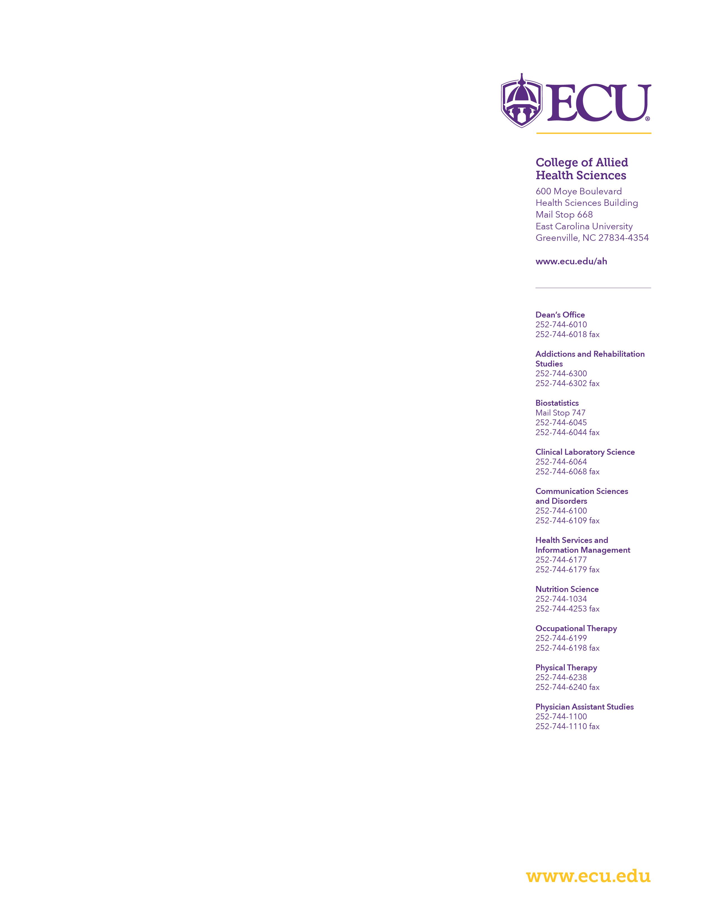
July 1, 2021

Re: Letter of Intent RFA AG-12-005

Dear Dr. PROGRAM OFFICER:

This letter indicates our intent to submit a proposal in response to the funding opportunity, “NAME of RFA”, RFA XX-XX-XXX. The specifics of the proposed project are outline below.

Descriptive Title

Investigator
PD/PI:

Key Personnel

Additional key personnel are to be determined

Participating Institutions East Carolina University

Submitting Institution East Carolina University

Number and Title of FOA RFA-XX-XX-XXX: Title of FOA

Please don’t hesitate to contact me if you need additional materials

or information.

Best regards,
CAHS Researcher, PhD
Associate Professor
Department of ….
East Carolina University
Phone: _________
Fax: ____________
email

