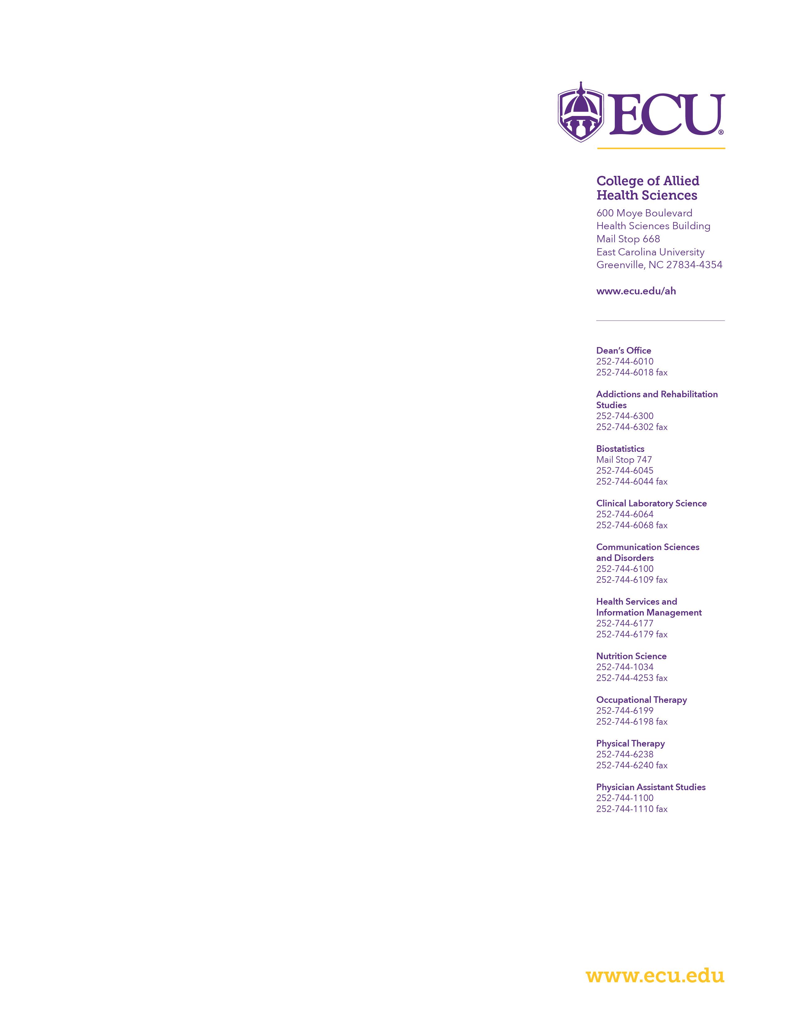
July 1, 2021

Re: Grant Proposal Application

To Whom it May Concern:

Please find enclosed the application titled, “____” for review and renewal consideration. I am the principal investigator for this work. Any resulting award should reflect the recipient as “East Carolina University”.

Please assign this application to the following Institute – ___

Please assign this application to the Scientific Review Group, ___.

Your consideration of this application is appreciated. Please contact me at (XXX) 744-XXX or myemail@ecu.edu if you have any questions regarding the technical portions or Anniette Keyes at (252) 328-9535 if you have any administrative, budgetary, or award questions.

Best regards,

CAHS Researcher, PhD
Associate Professor
College of Allied Health Sciences
East Carolina University

